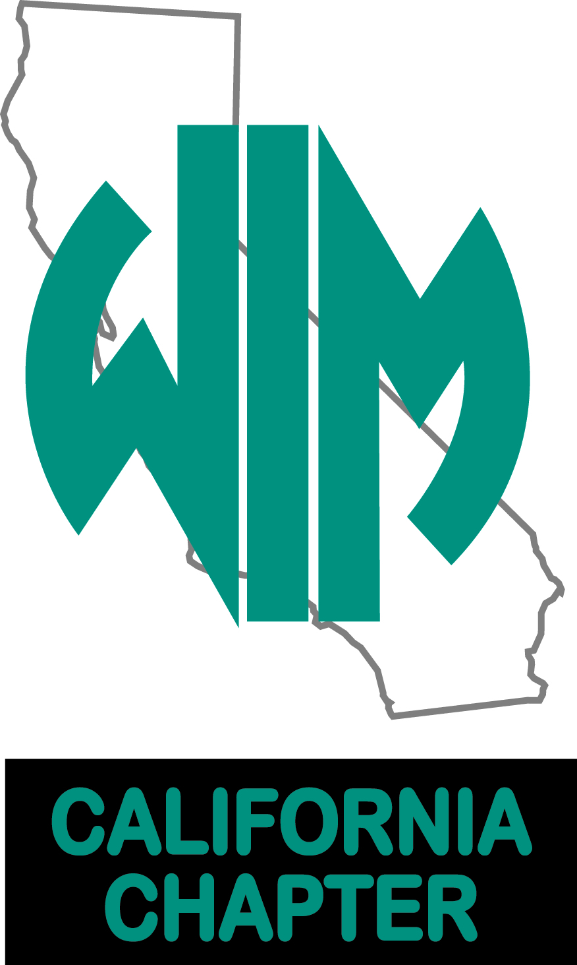

**22nd Annual Benefit WIM Golf Tournament**

Four Person Scramble: Limit 36 teams

They will fill up fast, so register NOW!!

Each golfer receives: A fun filled day including a continental breakfast, free shirt, goodie bag, putting contest entry, unlimited use of golf range, awards luncheon and 18 challenging holes on a private Robert Trent Jones Championship golf course.

Post checks payable to WIM-California Chapter to PO Box 146, Oro Grande, CA 92368.

Spring Valley Lake Golf Course Registration: 7 AM Contact

13229 Spring Valley Parkway Shotgun Start: 8 AM Jessica Gammett 760-269-1135

Victorville, CA 92395 ***TAX ID 2585951*** jgammett@calportland.com or

Desirea Haggard 626-691-1966

dhaggard@calportland.com

***April 27th***

* Platinum Sponsor $2,500 (only two available)

Golf for four, Two carts, Tee Sponsor sign, Golf shirts with company logo, Banner at tee-off, Unique Platinum Sponsor Award presented at luncheon, prominent recognition on social media and in press release.

* Major Sponsor $1,100

Golf for four, Two carts, Tee Sponsor sign, Major Sponsor Award presented at luncheon, recognition on social media and in press release.

* Business Sponsor $800

Golf for four, Two carts, Tee Sponsor sign, recognition on social media and in press release.

* Tee Sponsor $200 each

|  |  |  |  |  |
| --- | --- | --- | --- | --- |
| Name | Company | Email | Phone | Shirt Size |
|  |  |  |  |  |
|  |  |  |  |  |
|  |  |  |  |  |
|  |  |  |  |  |

SPONSORSHIPS – Must be paid by April 17, 2020