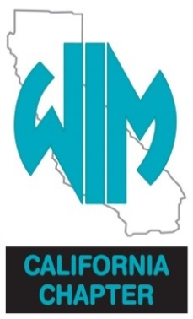
2019
CALIFORNIA CHAPTER
WOMEN IN MINING
SCHOLARSHIP INFORMATION

Five $2,500.00 Scholarships

WOMEN IN MINING (WIM) is a nationwide organization comprised of individuals employed in, associated with, or interested in mineral education and the mining industry. Women in Mining is dedicated to educating students, teachers, and the general public about the importance of minerals in our daily lives.

Founded in 1990, WIM California Chapter is, above all else, an educational group. We are women and men. We are environmental engineers, geologists, miners, office workers, safety engineers, State and Federal regulators, engineers, educators, and much more. We work together toward a common goal: To raise public awareness about the value of minerals and their direct correlation to our standard of living.

Those committed to obtaining an education leading to a degree through a course of study related to mining, geology, engineering or environmental studies are encouraged to review these WIM California Chapter scholarship guidelines for eligibility requirements and to submit their application for consideration.

APPLICANT PLEASE NOTE
You have the ultimate responsibility to ensure that the scholarship application, all forms and transcripts, are received by the WIM California Chapter representative on or before March 8, 2019 (postmarks by this date are accepted). Upon notification of winning an award, you will be responsible for collecting the award before the end of this calendar year or the award will be considered forfeited.

SCHOLARSHIP REQUIREMENTS AND GUIDELINES
Women in Mining, California Chapter, seeks scholarship candidates who possess a commitment to obtain an education leading to a degree through a course of study related to mining, geology, engineering or environmental studies.

Applicants must be at least a senior in high school or currently enrolled full time in college. Applicant must currently maintain a 3.0 or higher grade point average. The successful scholarship finalists must provide proof of full time enrollment in secondary education prior to receiving the award. The scholarship grant shall be applied toward the cost of tuition and/or course expenses as selected by the recipient, the amount not to exceed the scholarship grant.

All information must be received by the scholarship committee no later than March 8, 2019. WIM California Chapter scholarship committee will review all completed applications, current transcripts (unofficial transcripts are acceptable, however at the discretion of WIM official transcripts might be requested), and scholarship essays. The scholarship committee will select recipients and present their decision to the WIM Board of Directors. Following the Board’s approval, all applicants will be notified of the Committee’s decision.

Scholarships are not automatically renewed, but each recipient could be considered for subsequent awards if he/she provides evidence of continued interest in mining, geology, engineering or environmental studies with emphasis in science and/or related fields. Recipient must be in good standing in a program related to a degree. Prior scholarship recipients must reapply annually for consideration.

This scholarship is for California Residents only, they must be a U.S. Citizen, and may attend a College or University outside California.

The California Chapter of WIM is an equal opportunity organization.

APPLICATION INSTRUCTIONS
Please complete, enclose, and mail, application form, transcripts, and one-page essay to:

Attn: Jamie Ambrose
WIM - CalPortland
19409 National Trails Highway
Oro Grande, CA. 92368

No emailed applications will be accepted.

Type or print using blue or black ink. Use N/A if question does not apply.

You have the ultimate responsibility to ensure that the application form, essay, and transcripts are received by the WIM Scholarship Committee no later than March 8, 2019.

If you have questions, please contact Jamie Ambrose at (760) 269-1121 or by email: jambrose@calportland.com

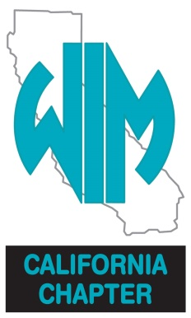

2019
CALIFORNIA CHAPTER
WOMEN IN MINING
SCHOLARSHIP APPLICATION FORM

Deadline: March 8, 2019

Name:
Mailing Address:
City: |  |  |  |  | State: |  |  |  |  |  | Zip Code:
Home Phone: |  |  |  |  |  |  |  |  |  | Cell:
Email:
Major |  |  |  |  |  |  |  |  | Emphasis:
Current School: |  |  |  |  |  |  |  |  | Year in School:
Approximate Graduation Date: |  |  |  |  |  |  |  |  |  | Overall GPA:
Career or Field of Study you plan to pursue after graduation:
University or College of Choice:
1st Choice:
2nd Choice:
3rd Choice:

On a separate sheet of paper, write a one-page essay stating your future plans.

